PARANALAR International Journal Of Communication (PIJoC)

Vol. 1, No. 3, September 2026, pp. 1-16
ISSN: XXX-XXX-2026
Research Article
https://paranalar.org/index.php/ijcp/index

Title no more than 15 words
1st Author first and last name ^{1*}, 2nd Author’s first name and last name ²

¹ Title, Department, Institution, City, Country
² Title, Department, Institution, City, Country

*Corresponding Author: 1234@gmail.com

Citation: P. Sid and J.Ci. yyy, “The role of xxxxxxx,” PIJoC, vol. xx, no x, pp.

ARTICLE INFO |  | ABSTRACT
Received:  Accepted: |  | The abstract should be written in 9-point Georgia font, single-spaced. The abstract should be between 125 and 200 words long and should contain four things: (1) the purpose/basic research question; (2) the theory and methods used; (3) a summary of the results/analysis of the findings; and (4) conclusions.  Keywords: keywords should be 5 and separated by a comma)

INTRODUCTION
Follow these writing guidelines. The background section should be written in 10-point Georgia font, single-spaced. The background should include and explain the context of the communication problem being studied, the empirical phenomena underlying the research, data or facts demonstrating the existence of the problem, the relevance of the problem to communication studies, a summary of previous related research, research gaps, and the urgency and contribution of the research to the development of communication science and practical problem-solving.
In scientific articles, a good introduction generally moves from explaining the research area to identifying knowledge gaps and finally to confirming the research direction. This pattern is also common in social science articles, including communication. The background should demonstrate why communication phenomena are important to study, whether in the context of mass, digital, political, organizational, marketing, or cultural communication. Therefore, the author needs to present the relationship between the phenomenon, theory, and previous findings so that readers can clearly see the research's position.
In this paragraph, the author should explain the urgency of the research, e.g., this research starts from the assumption that literacy problems are at the intersection of educational inequality, social stigma, and limited learning infrastructure. Therefore, the approach needed is not just a conventional reading, writing, and arithmetic program, but an intervention model that integrates literacy campaigns, AI-based learning, and community empowerment.
Furthermore, at the end of the background, the author should explicitly state the research question and/or objectives. These questions and objectives should logically flow from the problem statement, the research gap, and the topic's urgency outlined in the previous paragraph. All background arguments should be supported by APA-style citations, with priority given to journal articles published within the last five years.

LITERATURE REVIEW
Theory and Concepts
The literature review should be written in 12-point Georgia font, single-spaced. This section contains conceptual and conceptual descriptions relevant to the research topic. The literature review should be analytical and synthetic, demonstrating the relationships among concepts, theories, and prior research.
The literature review should not only include definitions but also develop academic arguments that demonstrate the research position, outline developmental studies, and identify the research areas that form the basis of this research. This subsection explains the key concepts used in the study, including definitions, dimensions, indicators, and their relevance to the research focus.
Research Gap
This subsection describes aspects that are unanswered, inadequately studied, or remain problematic in previous research.
Framework
This section outlines the research's logistical flow, linking the analysis, theories, and problem focus as the basis for the research.
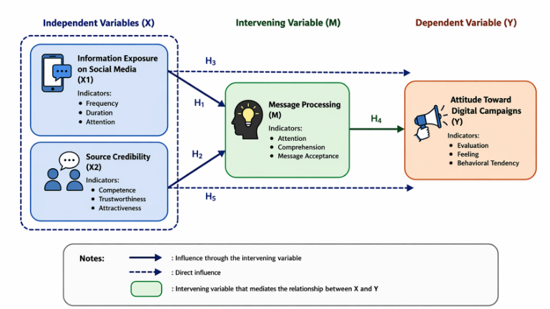
Figure 1. Framework (Georgia 9 pt font, centered)
Source: Processed by researchers based on theoretical concepts (2026)

Hypothesis (Quantitative)
This chapter presents the research hypothesis formulated based on theory and previous research, particularly for quantitative research.

METHODOLOGY
The Research Methods section should be written concisely and systematically. This section should include at least the following: research approach and type, research location and time, research subjects and/or objects, population and sample or informants, data sources and types, data collection techniques, operational variable definitions (if necessary), data analysis techniques, and data validity and reliability tests. The author should explain the methods operationally so that the research process can be clearly understood.

RESULTS AND DISCUSSION
Overview of Research Results
This sub-chapter contains a brief description of the main research findings. The author can explain the context of the findings, the amount of data, the characteristics of the respondents or informants, the unit of analysis, and the scope of the results to be discussed. This section serves as an introduction to the more detailed results.

Presentation of Research Results
This sub-chapter presents the research findings in a structured manner, aligned with the research focus. Results can be organized by variables, indicators, themes, categories, units of analysis, or the sequence of research questions. Data can be presented in narrative form, tables, graphs, charts, interview quotations, or matrix analysis. The author should ensure that each table or figure is numbered, titled, and, when necessary, sourced.
Table 1. Georgia 9 pt font, centered
Hypothesis | Relationship between variables | Coefficient | Sig. | Decision
H1 | Information Exposure → Message Processing | 0.45 | 0.000 | Received
H2 | Source Credibility → Message Processing | 0.39 | 0.001 | Received
H3 | Information Exposure → Attitudes towards Digital Campaigns | 0.28 | 0.012 | Received
H4 | Message Processing → Attitudes Toward Digital Campaigns | 0.41 | 0.000 | Received
H5 | Source Credibility → Attitudes Towards Digital Campaigns | 0.22 | 0.031 | Received
Source: Research data processing (centered)

Example of a narrative table discussion:
The results of the hypothesis test indicate that information exposure and source credibility both influence message processing. This finding demonstrates that exposure intensity alone is insufficient; the quality of the source also determines how the message is understood and received by the audience. In the context of digital communication, this finding underscores the importance of combining message frequency and communicator legitimacy.

Analysis of Findings
This sub-chapter explains the patterns, relationships, trends, or initial meanings of the data presented. In quantitative research, this section may include the results of statistical tests and a brief explanation of those results. In qualitative research, this section may include categorization, main themes, relationships between themes, or initial interpretations of the field data.

Discussion
This sub-chapter is the core scientific analysis that connects the research findings to theories, concepts, and previous research. The author should explain whether the findings support, extend, measure, or contradict previous theories and research. The discussion should position the findings within the broader academic context and emphasize the research's contributions.

Implications of Findings (optional but recommended)
This sub-chapter contains the theoretical and practical significance of the research findings. Theoretical implications explain the research's contribution to the development of concepts, models, or theories. Practical implications explain the benefits of the findings for institutions, society, the media industry, organizations, or other relevant parties.

CONCLUSION
The conclusion section should be written concisely and directly refer to the research results and discussion. The conclusion should address the research question or achieve the research objectives, emphasizing the main findings. The conclusion should not simply repeat the discussion but summarize the core analysis results in a statement that demonstrates the research's meaning, contribution, or implications. The author may briefly discuss the theoretical and/or practical implications of the research findings. If necessary, suggestions or recommendations may be provided in a limited manner and relevant to the research findings.

ETHICAL DECLARATION

Acknowledgements: Authors should acknowledge individuals, institutions, funding bodies, or organizations that contributed to the research or manuscript preparation but do not qualify for authorship, including relevant grants, assistance, or support.

Conflict of interest: Authors must disclose any financial, professional, personal, or institutional interests that could influence the research, interpretation, or publication of the manuscript. If none exist, this should be clearly stated.

Financing: Authors should disclose all sources of financial support for the research and publication, including grants, institutional funding, or sponsorship. If no funding was received, this should be clearly stated.

REFERENCES
The bibliography should be written in the American Psychological Association (APA) 7th edition format and compiled using a reference management tool such as Mendeley, Zotero, EndNote 9, or a similar tool. Furthermore, when writing an article, it is recommended to use credible journal references, at least 20 articles published in the last 5 years. All bibliographies must include DOI links (except for classic books, which do not have DOI links).

Sidharta, V., Lubis, D. P., Sarwoprasodjo, S., & Seminar, K. B. (2024). Decision making in ambiguous situations: Determining recipients of cash social assistance in Indonesia. Multidisciplinary Science Journal, 7(6), 2025278. https://doi.org/10.31893/multiscience.2025278
Putra, J.A., & Sidharta, V. (2025). Relationship Quotes As A Sense-Giving Medium: A Study Of Emotional Interaction And Perception on TikTok. Jurnal Ranah Komunikasi (JRK), 9(2), 116–125. https://doi.org/10.25077/rk.9.2.116-125.2025
Alperstein, N. M. (2019). Celebrity and mediated social connections. London, UK: Palgrave Macmillan.

